Password less connectivity between 2 server
- Create two instance with SG ssh(22)
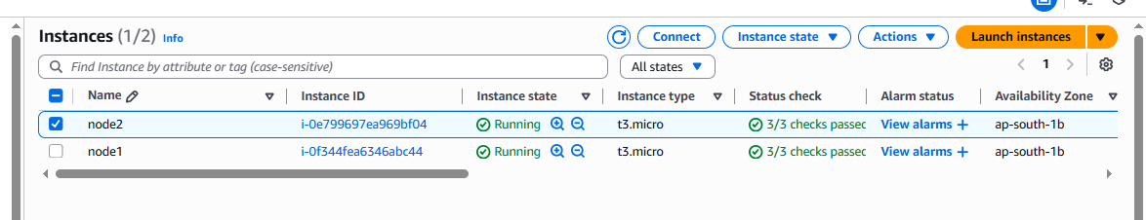
Login to on node 2 server and run the below mention command
passwd ec2-user and put the password (anything)
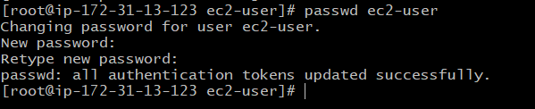
Go to the cd /etc/ssh path and open highlighted file

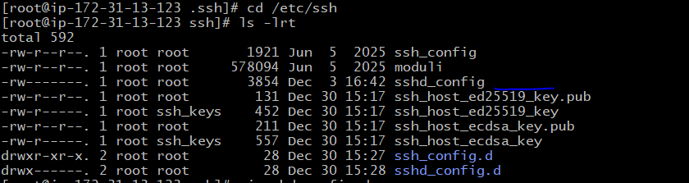
Once open highlighted file need to convert PasswordAuthentication no to yes and save the file :wq!
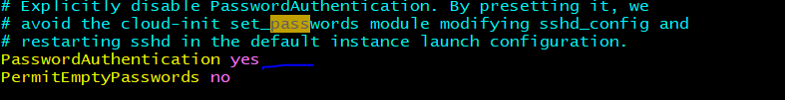
Then check the authenticatication converted or not to yes using grep command
grep -i pass sshd_config
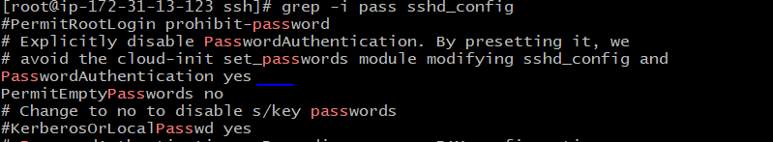
Then restart the node2 server using below command
systemctl restart sshd
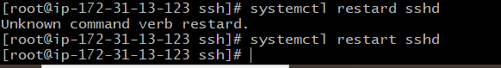
Once complete above steps need to login on another server (Node 1)
Run below command on Node 1 Server to generate the key
ssh-keygen and enter 3 times
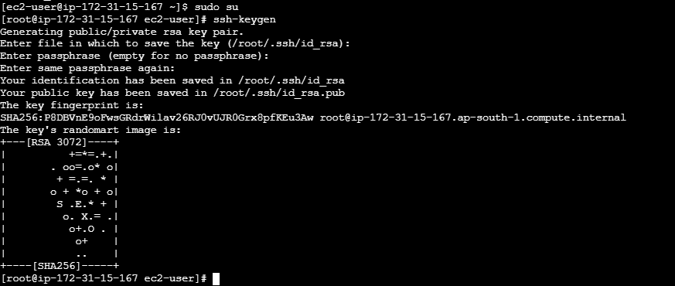
ssh-copy-id ec2-user@3.111.29.239 ------mention ip is public IP of node 2
once hit above command will ask passwd, need to put pass which is set on node 1 server
without passwd successfully connected on other server
ssh ec2-user@3.111.29.239
